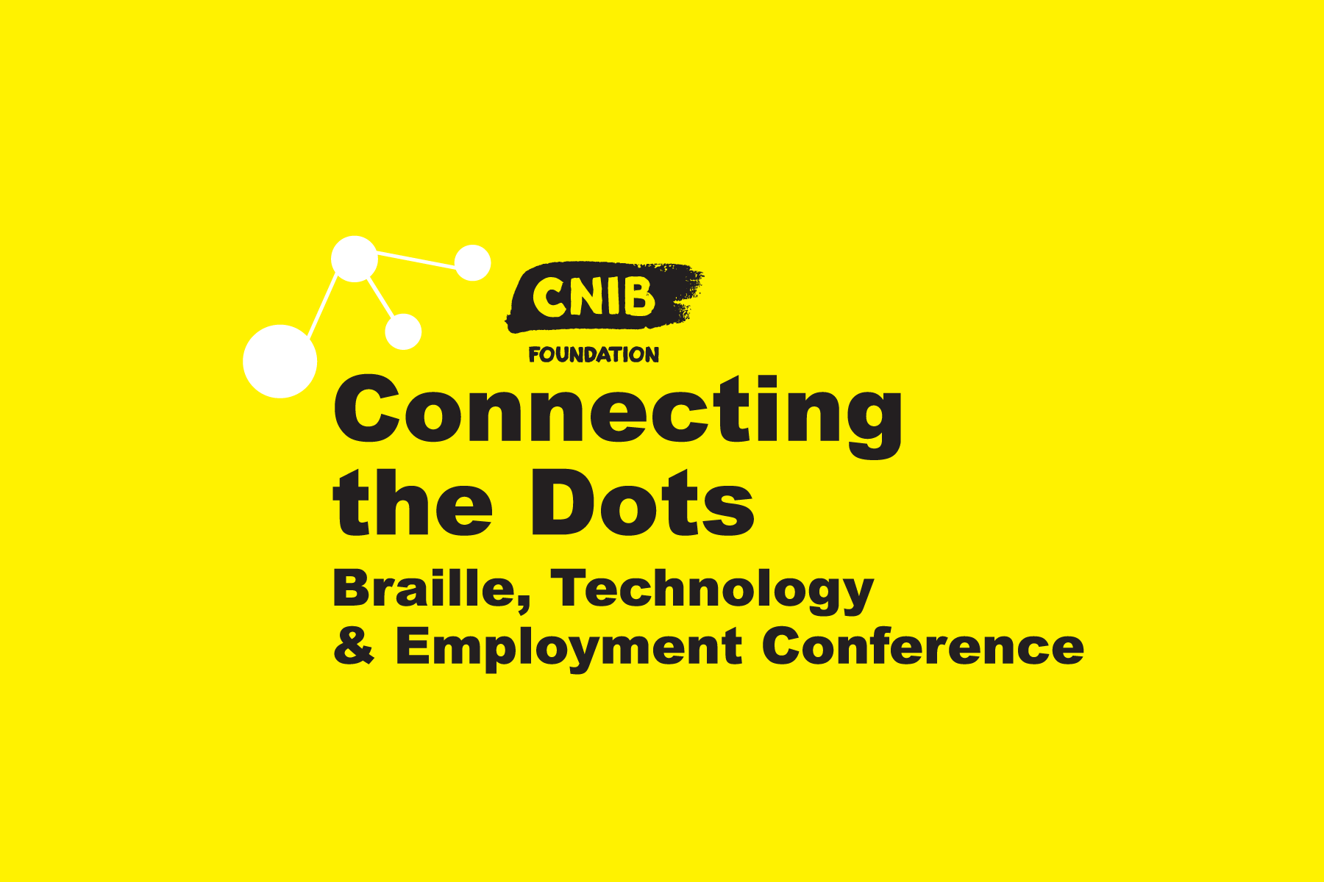
Tuesday, October 29 & Wednesday, October 30, 2019

MaRS Discovery District, Toronto

Day 1 – Tuesday, October 29
Opening Remarks & Keynote Presentation by Deloitte (8:30 a.m. – 9:30 a.m.)
Session 1 (9:45 a.m. – 10:45 a.m.)
101. The ABC's of iOS and VoiceOver
The iPad is an incredible educational tool, but, more often than not, children with sight loss are not introduced to modern technology until much later than their sighted peers. The ABC's of iOS manual ensures educators and family members have the required tools to teach a child who is blind or partially sighted how to use iOS. The manual specifically addresses age-appropriate VoiceOver skills for children, ages 3-8, who are or may become braille readers, dual media, or auditory readers. By introducing technology to children at an earlier age – and providing them with the skills and training to operate it – we're empowering children to thrive developmentally and academically.
Presenter: Suzanne Decary-van den Broek, Executive Director, Ontario South, CNIB Foundation, Rhonda Underhill-Gray, Program Lead, Beyond the Classroom, CNIB Foundation
102. Inclusive Media – Real time (cc, av/dv)
This session will introduce Ryerson University's new course series, Inclusive Media: Real-time Closed Captioning (CC) and Audio Description/Described Video (AD/DV). Attendees will experience sample content and gain knowledge about the latest live closed captioning and audio description/described video techniques and technologies used to create inclusive and accessible broadcast content for a variety of audiences.
Presenter: Margot Whitfield & Marie-Catherine Rombaut, Inclusive Media and Design Centre, Ryerson University
103. BrailleNote Touch+
The ever-innovative BrailleNote Touch just became the BrailleNote Touch+ combing the simplicity and accessibility of a note taker with the power and efficiency of a modern smartphone or tablet. Supported by Android Oreo platform, it expands the entire user experience to fulfill today's digital expectations. Join us to find out why this new cookie is hands down the most up-to-date, simple and powerful solutions to optimize Braille efficiency in today's classroom.
Presenter: Michel Pepin, Canada Sales Director, HumanWare, Peter Tucic, Brand Ambassador - Blindness Products, HumanWare
Session 2 (11 a.m. – 12 p.m.)
201. Introducing Canute
A new portable Braille E-Reader, this multi-line braille book reading device will revolutionize the way we consume electronic Braille. With nine lines of braille and 40 cells in each line, there are many possibilities for accessing Braille Math, Music, etc. Join us to learn more about Canute!
Presenter: Jason Fayre, National Lead, Accessibility and Assistive Technology, CNIB, Kim Kilpatrick, Coordinator, Get Together with Technology
202. Zenbo - AI Robotics
Students at Ontario Tech University are engaged in a project to program Zenbo, a robot produced by Asus, to read human emotions. This workshop will demonstrate the emerging capabilities of robotics and artificial intelligence to interact within an environment.
Presenter: Alvaro Uribe Quevedo, Ph.D., Assistant Professor, Ontario Tech University, Connor Combdon student, Ontario Tech University, Andrew De Lima Salgado, Manollo Guedes, Visiting Researcher, Ontario Tech University.
203. Voice. Advocacy. Service
Knowing how to advocate is what can truly affect change. This session will teach persons with disabilities, allies and employers how their individual and collective actions can accelerate the normalization of universal inclusion and diversity.
Presenter: Ingrid-Palmer White, Community Outreach Coordinator, CNIB Foundation
Lunch & Creative Writing Contest (12 p.m. – 1 p.m.)
Tech Panel (1:00 p.m. – 1:30 p.m.)
Session 3 (1:45 p.m. – 2:45 p.m.)
301. CNIB's Social Enterprise
Frontier Accessibility is a CNIB Social Enterprise supporting businesses and organizations to ensure that all Canadians with disabilities can benefit from barrier-free communities and workplaces so everyone can participate fully and equally. Our approach to providing customized solutions ensures that all organizations will have the tools to break down barriers and champion a culture of inclusion. Experience the latest products, services, and customized solutions available to individuals, businesses and employees to achieve our goal of an equitable and accessible Canada by 2030.
Presenter: Andrea Vose, Sales Manager, Frontier Accessibility, Stephen Ricci, Portfolio Manager, Frontier Accessibility
302. Working Age Canadians with Vision Loss
With academic and professional credentials across a wide range of disciplines, the CNIB Foundation’s research team is passionate about contributing to knowledge and understanding of blindness in Canada and around the world. This session will deliver an overview of recent employment research conducted by CNIB - providing an employment profile on working age Canadians with sight loss in the following areas: people with sight loss in management positions, what size company individuals with sight loss tend to work for, and what the earning potential for those who have been promoted and those who are self-employed.
Presenter: Christine Robbins, Specialist, Strategic Research, CNIB, Mahadeo Sukhai, Ph.D., Head of Research and Chief Accessibility Office, CNIB
303. What is CAD? (Certified Audio Describers)
This workshop will provide attendees with an overview of the audio description certification process that is occurring on behalf of the Academy for Certification of Vision Rehabilitation & Education Professionals (ACVREP) in the United States. We will present a review of the process, an update from the Body of Knowledge and Scope of Practice subcommittees, the implication for Canada, and invite discussion and perspectives from the audience.
Presenter: Deborah Fels, Professor, Ted Rogers School Information Technology Management, Emily Harding, Described Video Specialist, AMI
Session 4 (3 p.m. – 4 p.m.)
401. Connecting the Dots with Innovative Design Thinking
In a fast-paced and complex world, the need to develop innovation skills is crucial. Explore an introduction to a human-centered design approach for tackling innovation barriers. This session will help you develop creative and effective processes, strategies and solutions to support innovation. Innovation Thinkers use a process powered by empathy to create efficient programs that meet their client's needs and dreams.
Presenter: Carolina Cohoon, Specialist, Deafblind Community Services
402. Soundscape
As the next step on the journey to enabling a more accessible Canada for all, Microsoft Canada announced the availability of Soundscape, an app that empowers people who are blind or partially sighted to explore the world around them through a 3D audio experience.
Presenter: Damian Milczarski, Education Expert- Microsoft
403. Navigating the Digital Wayfinding Landscape
Navigating the Digital Wayfinding Landscape: Tips, Tools and Techniques. As the world around us is ever-changing, many municipalities, transit agencies and technology companies have come forward to address the challenges of travelling in unfamiliar environments. This session will focus primarily on the Greater Toronto Area, but the technology tools covered in this session work in any locale.
Presenter: Debbie Gillespie, Built Environment & Transit Consultant, CNIB Foundation
Day 2 – Wednesday, October 30
Opening Remarks & Keynote Entrepreneur Panel (8:30 a.m. – 9:30 a.m.)
Session 5 (9:45 a.m. – 10:45 a.m.)
501. Quote, Unquote – A UEB Update
After many proposals (both subtle and drastic), a worldwide survey and extensive discussions, a revision to the UEB rule on quotations and the apostrophe have been approved. This session will provide attendees with a detailed examination of the revised rule and a look at how it will affect your braille.
Presenter: Phyllis Landon, Code Maintenance Office of ICEB
502. Blindness, Mental Health and Employment
While much research has been done on the factors relating to blindness and employment in general, more information on the relationship between blindness and mental health in the employment context is badly needed. An examination of the existing literature presents several themes useful for the development of future research questions and hypotheses. These include the role of discrimination and perceived stigma, and the relationship between self-efficacy, locus of control, and employment status.
Presenter: Ashley Shaw, Accessible Community Engagement Coordinator, CNIB Foundation, Mahadeo Sukhai, Ph.D., Head of Research and Chief Accessibility Office, CNIB
503. Flagship Service Canada Centre
In this session, Carly Brisbane from Service Canada will talk about the design and implementation of their Flagship Service Canada Centre. Learn how Service Canada demonstrated inclusivity by design by bringing different perspectives to the table; collaborating with persons with disabilities, accessibility stakeholders, clients and staff, moving beyond accessibility to inclusive co-creation.
Presenter: Carly Brisbane, Director, Planning, Accessibility and Strategic Analysis, Service Canada
Session 6 (11 a.m. – 12 p.m.)
601. The Good, the Bad and the Fabulous!
If someone had told me ten years ago that I could access nearly any book I wanted and that I could even read it in braille, I would never have believed it. Automated braille translation (such as Apple’s braille support) has made this a reality. However, generating braille without human intervention has its challenges. When is automated braille a viable option, when is it problematic and when is it quite simply a dream come true?
Presenter: Jen Goulden, Project & Quality Manager, Crawford Technologies
602. Fireside Chat
Join members of the AMI team and sight loss community for an intimate discussion/fireside chat about technology and the ins and outs of how it can impact employees, teammates and workplaces. Kelly will discuss how he multitasks and his innovative disciplines in the radio/entertainment industry.
Presenters: Kelly MacDonald, Host of AMI's Kelly and Company, Andrew Morris, Commissioned Content AMI-tv
603. Unbound, Book Club panel
Learn more about CNIB’s newest national literacy initiative for adults. Are you a reader of accessible formats or know someone who is? Maybe you’re looking for your next great read or want to connect with an inclusive community of book lovers. Join us to hear more about our Facebook Group and Podcast series.
Presenter: Ryan Hooey, Program Lead Advocacy and Accessible Community Engagement, CNIB Foundation, Natalie Martiniello, Member of the CNIB Book Club, Joe Bernard, CNIB Volunteer, James Denas, Podcast Host.
Lunch & Presentation of the Youth Advocacy Award (12 p.m. – 1:30 p.m.)
Keynote presentation: Dave D’Silva
Session 7 (1:45 p.m. – 2:45 p.m.)
701. BANA: Provisional Guidance on transcribing MATH
"BANA's Provisional Guidance on Transcribing Mathematics in UEB." Since UEB Guidelines for Technical Material provides very little guidance for format, BANA is publishing a document to provide additional formatting suggestions to achieve a reasonable level of standard transcription.
Presenter: Lorraine Banks, Volunteer UEB Transcriber and Instructor, CNIB
702. Venture Zone Game
Build a company! Make millions! The Venture Zone Game is a business simulation game for iOS that teaches players to run a business and learn entrepreneurial strategy⁠—hiring, marketing, branding, ordering products, negotiating retail deals and more. This interview-style session will describe totem Learning’s experience of developing the Venture Zone Game for CNIB⁠— including the lessons on building a game with accessibility in mind. Attendees are encouraged to download The Venture Zone Game from the Apple App Store to participate in a demo of the game during this session.
Presenter: Spencer Holmes, Director, Totem Learning Ltd. and Nathan Hester, Lead Developer, Totem Learning Ltd.
703. Know Your Rights
In this session, we'll review Ontario's human rights laws and community resources/support. Learn how to identify legal issues and discrimination in the context of employment, navigate the legal system, and self-advocate against discrimination.
Presenter: Avery Au, Lawyer and CNIB's Know Your Rights Lead, Kat Clarke, Manager of Advocacy and Government Affairs, CNIB Foundation, Shannon Kinch, Lawyer and Project Coordinator, CNIB's Know Your Rights
Session 8 (3 p.m. – 4 p.m.)
801. 4 C's of Accessibility
As innovative solutions are developed to improve accessibility in public spaces, the workplace, and beyond, social awareness and understanding of accessibility issues is more important than ever. This workshop introduces the 4 C's of accessibility (collaboration, customization, communication and connection) through hands-on simulations, discussions, and opportunities to breakdown misconceptions about sight loss and blindness. This session is intended for all individuals hoping to make their workplace, program, or services more inclusive.
Presenter: Natalie Minnema, Co-Founder and Accessibility Consultant, Two Canes Consulting and Sarina Cormier, Co-Founder and Accessibility Consultant, Two Canes Consulting
802. Employment of Guide Dog Handlers
With academic and professional credentials across a wide range of disciplines, the CNIB Foundation’s research team is passionate about contributing to knowledge and understanding of blindness in Canada and around the world. This session will deliver an overview of employment research conducted by CNIB to better understand the employment of guide dog handlers in Canada.
Presenter: Danika Blackstock, Research Associate, CNIB
803. UEB Standing Alone Rule
The standing Alone Rule demystified. One of the benefits of UEB is that it is unambiguous by design. But one of the more difficult concepts to grasp is the Standing Alone Rule. During this session, we will provide concrete examples of the rule and explain its use. We welcome audience participation and look forward to discussing this rule during the session.
Presenter: Debbie Gillespie, Built Environment & Transit Consultant, CNIB Foundation, Darleen Bogart, National Convenor, CNIB Foundation

CNIB Work Zone
Visit the CNIB Work Zone at Connecting the Dots! Network with professionals to develop and support your career ambitions.
At the CNIB Work Zone, you will have an opportunity to:
- have a professional headshot taken for your LinkedIn profile;
- strengthen your personal brand by connecting with an HR coach to receive feedback on your resume or LinkedIn profile;
- gain valuable career advice from influential people in the recruitment industry through networking with HR pros from Deloitte, HSBC, Meridian Rogers, and more;
- perfect your elevator pitch and practice your interviewing skills in our coaching corner;
- meet a vibrant community of entrepreneurs from CNIB Venture Zone and purchase their one-of-a-kind goods and services;
- and, learn about our upcoming digital e-commerce marketplace for entrepreneurs with sight loss.
Visit the Green Room to experience the CNIB Work Zone!

