2025 CNIB Lake Joe
Camp Programs
Enriching lives. Making memories. Building independence.
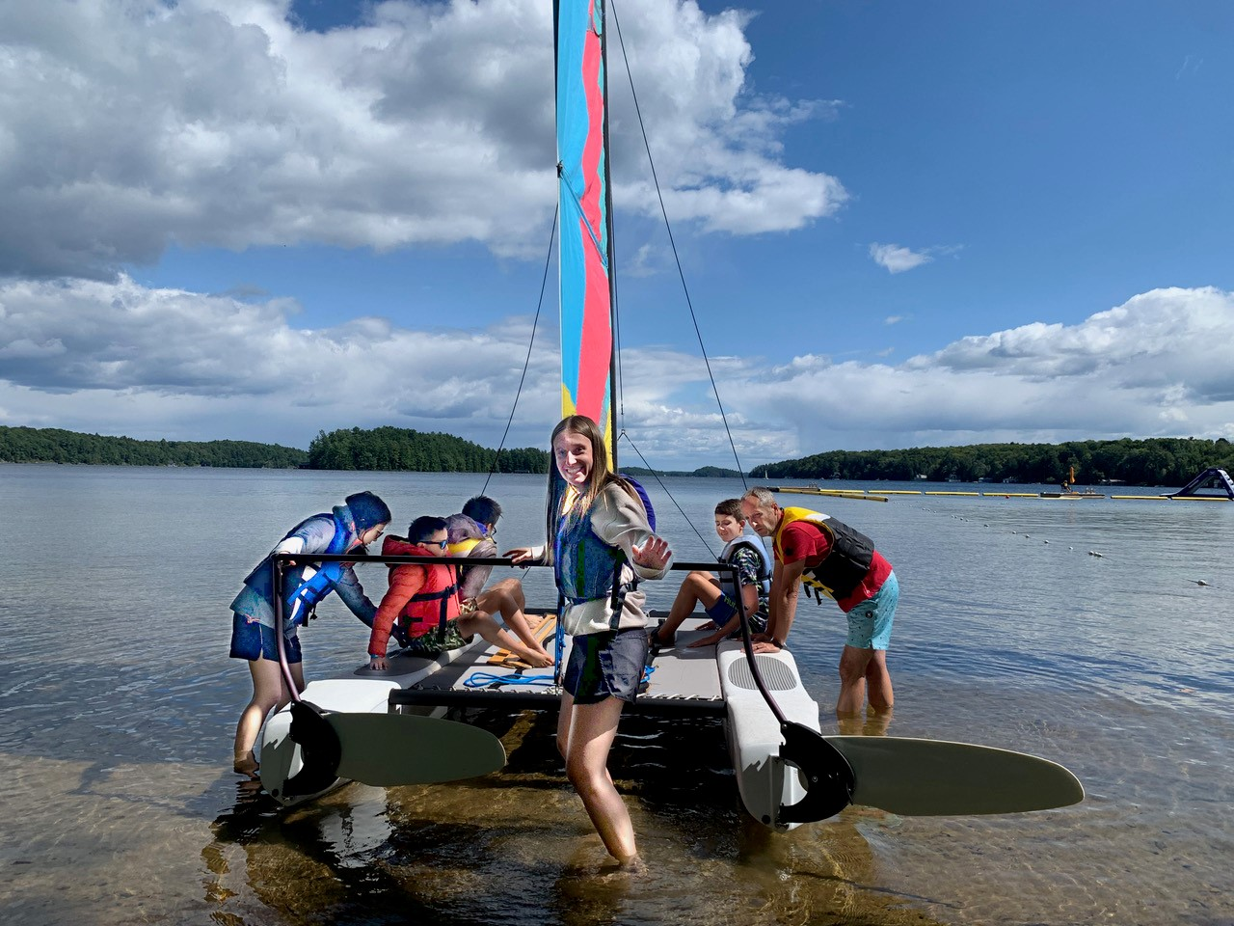

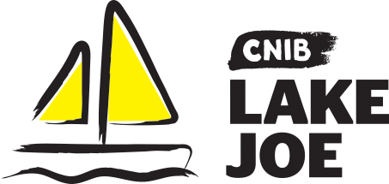

Table of Contents
Table of Contents 2
About CNIB Lake Joe 3
Children & Youth Programs 5
Adult Programs (19+) 10
Family Programs 14
CNIBLakeJoe@Home Virtual Programs 16
Programs Summary 17
2025 Program Fees 18
Application Process 21
Getting to Camp 23
Get Involved 24

Please note: CNIB Lake Joe may update or make changes to the 2025 schedule. Every effort will be made to keep the programs and fees as represented; however, unforeseen circumstances may result in the substitution or cancellation of a program. We appreciate your understanding and look forward to finding the perfect program for you and your family.

About CNIB Lake Joe
We are excited to share all the information you need to know about our CNIB Lake Joe 2025 season!
Since 1961, CNIB Lake Joe has been providing a distinctive combination of recreation and skills development in a safe, inclusive environment. Committed to providing meaningful experiences for Canadians with vision loss, it remains a one-of-a-kind camp in Canada. Located in the heart of Muskoka, CNIB Lake Joe is an accessible lakefront property that spans over 12.5 acres on the northwest shore of the picturesque Lake Joseph.
Proudly accredited by the Ontario Camps Association, a registered High Five organization and an affiliated member of the Lifesaving Society, CNIB Lake Joe upholds the highest standards of care and safety.
This year we are excited to offer a diverse range of camp programs including our signature “Partner Programs” in collaboration with staff teams from CNIB, CNIB Deafblind Community Services, INCA Québec and Vision Loss Rehabilitation Canada. We are also pleased to be partnering with blind sports organizations like Soccability Canada and Canadian Blind Hockey. Expect exciting new programs to dazzle and delight along with our classic beloved camp programs. We cannot wait to welcome you!
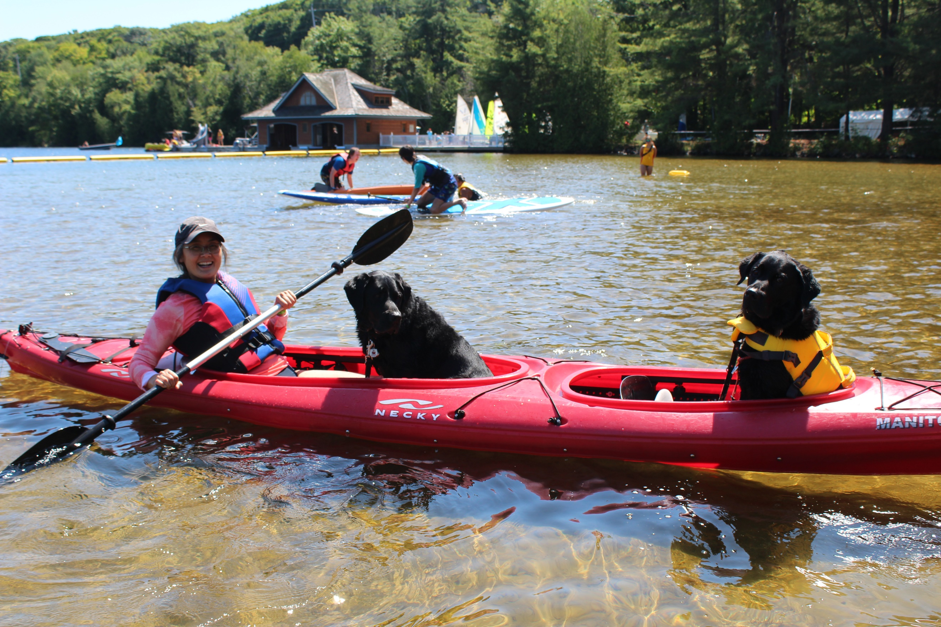

Here are just some of the activities you can enjoy at CNIB Lake Joe!
- Make a splash in Lake Joseph: Make waves with fishing, paddling (canoe, kayak, stand-up paddleboard), pontoon boat cruises, sailing, swimming, tubing, waterskiing, wakeboarding, and water sliding.
- Get your creative juices flowing: Crafts, dancing, music, pottery and talent shows.
- Get active and play: Archery, basketball, beep baseball, climbing tower, hockey, hiking, mini-golf, shuffleboard, soccer, tandem-bike riding, tennis, yoga and more.
- Skill up with new adventures: Learn something new every day, all in a fun, safe and supportive environment. Who knows what skills you will master next?
- Rest and unwind in style: Relax in the Multi-sensory room, enjoy a good book by the lake, gather around the campfire with friends – new and old. Find your perfect way to relax and recharge at your home away from home!

That’s not all! Don’t forget, there are lots of virtual programs – online and on the phone – at CNIBLakeJoe@Home where you can learn, laugh, and stay connected with your camp community year-round!

To apply, please visit: cniblakejoe.campbrainregistration.com

For more information, contact CNIB Lake Joe:
Email: LakeJoe@cnib.ca
Toll Free: 1-877-748-4028
Phone: 705-375-2630
Web: cnib.ca/LakeJoe
Address: CNIB Lake Joe, 4 Joe Finley Way, MacTier, ON P0C 1H0

Children & Youth Programs
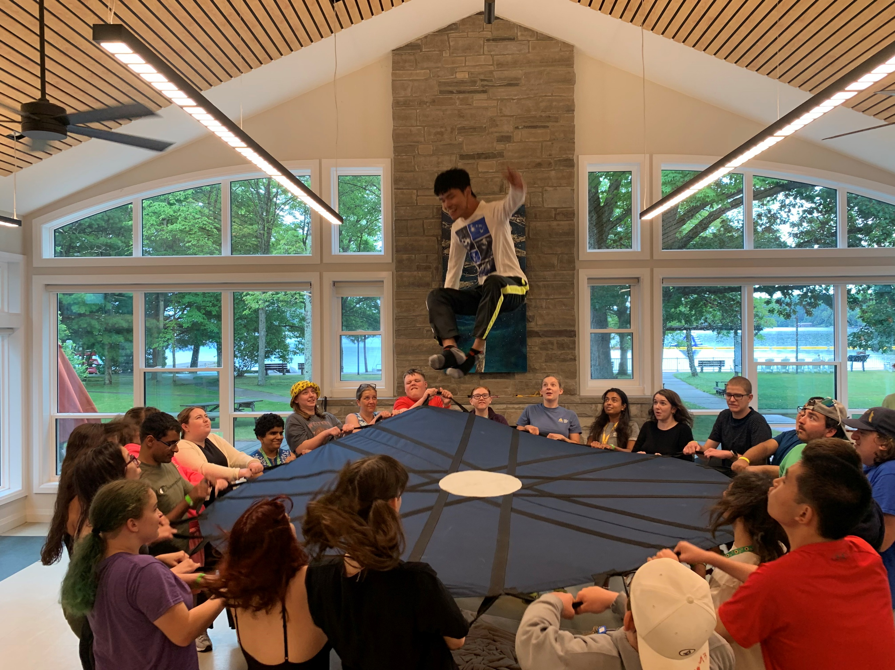
Our Children and Youth Programs are catered towards our younger guests who are blind, Deafblind, or have low vision with some programs open to sighted siblings and friends. In 2025, thanks to the incredible generosity of donors, we are excited to offer significantly discounted rates (see our Fees section for details) including ground transportation from select hubs across Ontario. Please review the “Important Program Points” included in the program descriptions for full details.

Welcome to CNIB Lake Joe’s Children & Youth Camp Programs
Pre-camp virtual orientation session
As part of the registration fee for all children and youth programs, we offer a Zoom meeting where you can meet others before camp, go over important details, learn what to expect and get answers to any questions you might have. This way you can spend all of your time at CNIB Lake Joe focused on fun, family and friends. Full details will be provided to registrants at the beginning of the season.

PLAY (Pushing Limits for Active Youth)
July 7-12, 2025 | Ages: 8-18
PLAY is a program for kids eager to get active and explore new sports. From 5-a-side soccer, archery, power showdown to the climbing wall, participants will dive into a variety of different sports and activities that encourage a fun and active lifestyle. Alongside these action-packed programs, there will also be wellness workshops, including healthy eating and self-care, to complement this adaptive sports component.
Note: This program is open to children and youth who are CNIB participants as well as sighted siblings and friends.

Camp Abilities
July 7-12, 2025 | Ages 8-18
Get ready to take your athletic skills to the next level with this goal-oriented sports program designed to boost performance! Whether you’re a seasoned athlete or just starting out, this program offers coaching and specialized sports training to help you reach your personal goals. You’ll have the chance to specialize in an Intro to Blind Hockey, Junior Blind Hockey or Watersports and focus on your chosen activity every morning. In the afternoons, you'll enjoy a variety of fun and active recreational pursuits at CNIB Lake Joe, providing the perfect balance of focus and fun. No matter which program you choose, you’ll get a perfect mix of skill-building and adventure in an inclusive and supportive environment. Whether you're on the ice, on the water, or trying something new, we’re here to help you succeed while having fun!

NEW! Intro to Blind Hockey:
This new introductory program, in partnership with Canadian Blind Hockey, is perfect for those with little to no prior experience in hockey. You’ll start with basic skating skills and gradually learn stickhandling, shooting, and even game play in a manner that is accessible to you. Under the expert care of Canadian Blind Hockey coaches this program is created to instill the blind hockey fundamentals. This program is designed to give you a fun, safe, and supportive environment to explore the new skills of blind hockey. If you need equipment to participate and it’s a barrier, please reach out to Alexis Peterson, Coordinator, Office & Registration at alexis.peterson@cnib.ca.

Junior Blind Hockey:
In partnership with Canadian Blind Hockey, this program will help you develop essential hockey skills such as skating, stickhandling, and shooting. You'll also work on game play scenarios and have the chance to scrimmage with fellow participants. To join this program, you'll need basic skating skills and access to your own hockey equipment, including shoulder pads, hockey pants, shin guards, elbow pads, gloves, a neck guard, mouthguard, helmet, skates, and a stick. To enhance skill building we will be using both blind hockey pucks and standard pucks for drills.

Watersports:
Dive into the excitement of waterskiing and wakeboarding! Participants in this program will focus on mastering these thrilling water sports. You’ll need basic swimming skills and the ability to lift yourself out of the water and onto a platform. Before jumping into the fun, you'll undergo a skills assessment at camp. Don’t worry about bringing your own equipment. Everything you need, from water skis to wakeboards, will be provided.
Note: This program is open to children and youth who are CNIB participants as well as sighted siblings and friends.

Summer Camp
July 28-August 2, 2025 | Ages 8-18
Experience the excitement and traditions of summer camp in our fully accessible facility. Try new activities, learn new skills and create new friendships – all while developing confidence and independence in a safe and supportive environment.
This program includes a combination of unique, smaller group-focused activities and traditional camp-wide games and programming. There is something for everyone of all skill levels! Activities will be varied including archery, pottery, swimming, music, art making, canoeing, 5-a-side soccer, mini-golf, the climbing wall and more! Campers will be grouped by age, allowing them to connect with peers, have fun, and fully enjoy the camp experience.
Note: This program is open to children and youth who are CNIB participants as well as sighted siblings and friends.

Partner Program: English as a Second Language (ESL) Immersion
July 28-August 2, 2025 | Ages 8-18
French-speaking children who are blind or have low vision will be joining the Summer Camp program to have fun and make friends while practicing and perfecting their English language skills.
For more information about this program and to apply, please contact Salma Moudrika, Program Lead, Children and Youth at salma.moudrika@inca.ca or 1-800-465-4622 ext. 236.

Leadership Camp
July 28-August 2, 2025 | Ages 15-18
Join a vibrant group of like-minded youth on the shores of the beautiful Lake Joseph for an unforgettable week of growth, fun and leadership development! This exciting program is packed with a dynamic mix of skill-building workshops, recreational activities and social events designed to help you unlock your full potential and have the best summer ever!
Throughout the week, participants will be empowered to share their aspirations, develop personal strengths and build courage and confidence to explore key leadership skills like public speaking, advocacy, self-awareness and personal branding. In addition to enriching leadership experiences, campers will also enjoy the recreational activities that make CNIB Lake Joe so unique. Under the guidance of skilled facilitators, campers will try new things, take on challenges, and discover what it means to be a leader in a fun, safe and supportive environment.
Important program points:
- This program is designed to equip participants with valuable leadership knowledge and skills that can be applied in all areas of life. To ensure a great fit and set participants up for success, the application for the Leadership program includes additional questions that help assess the readiness for the program and leadership potential.

Counsellor-in-Training (CIT)
July 28-August 9, 2025 | Ages 15-18
Who wants to be a camp counsellor? This exciting program is designed to give participants hands-on specific job experience and develop their leadership skills while having fun and taking an active role in camp life.
Over two weeks, you’ll take an active part in leadership workshops, skills development in various areas of camp programming and in-service training to better understand the skills required for staff roles at CNIB Lake Joe.
From learning goal setting to building campfires and facilitating activities, this program will empower participants to gain confidence and build the skills needed to potentially join the CNIB Lake Joe team as an official camp counselor.

Important program points:
- This two-week program is available for people who are blind or low vision and their sighted peers.
- The program includes a two-night camping trip to a local provincial park where participants will engage in team-building exercises and outdoor skill development.
- Prospective participants must fill out a supplementary application and participate in an interview with program staff prior to acceptance.
- Successful completion of this program guarantees an interview for future camp staff positions, but does not guarantee employment.

Partner Program: CNIB Buddy Dog Camp
August 18-23, 2025 | Ages 7-16
This one-of-a-kind program is designed specifically for CNIB Buddy Dog graduates and combines Buddy Dog training with exciting camp activities. Throughout the week, participants will have the chance to strengthen their bond with their buddy dog while enjoying recreational activities that promote independence, confidence, and teamwork. In addition to traditional camp recreational fun, participants work with expert CNIB Guide Dog trainers, receiving advice and support as they continue to grow with their Buddy Dog.
Important Program Points:
- This program is exclusively for CNIB Buddy Dog graduates who are paired with their buddy dog.
- Each participant must be accompanied by a parent or guardian for the duration of the program.
- The program includes Buddy Dog-specific training sessions, as well as recreational camp activities.
To find out more about the CNIB Buddy Dog Camp or the CNIB Buddy Dog Program, contact Miriam Mas, Program Lead, Buddy and Ambassador Dog Training at miriam.mas@cnib.ca or 343-997-2498.

Adult Programs (19+)
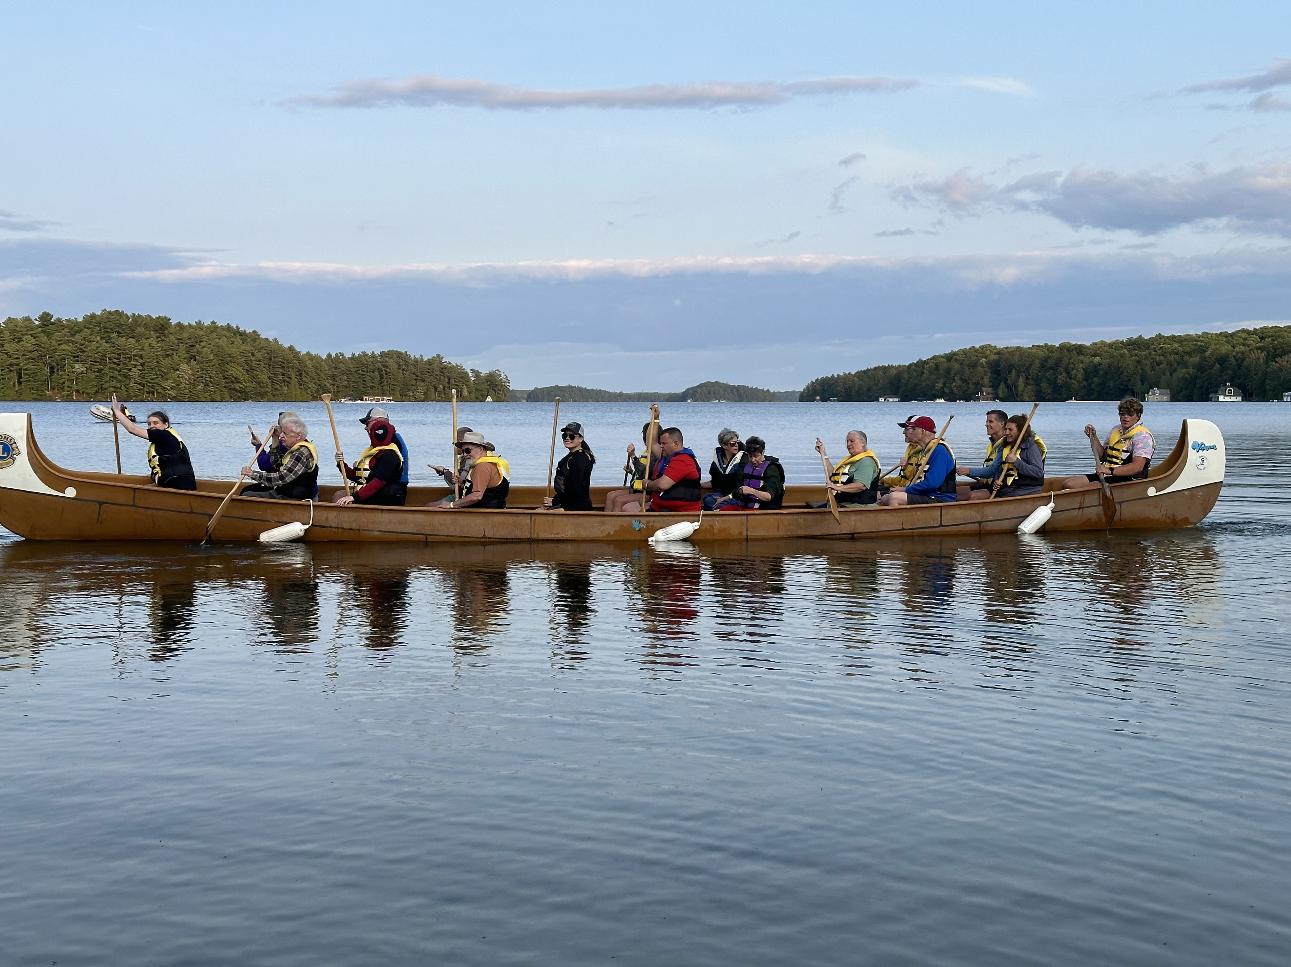
Our Adult Programs are designed to connect and engage the community, whether you're a first-time guest or returning for another fun experience. Some programs include structured activities, while others have "drop-in" options. Be sure to check the detailed descriptions below to find the right fit for you.
Important program point: To attend Adult Programs, participants should be independent and able to navigate the site with limited guidance after an initial introduction and site tour and will not require one-on-one support from staff. Participants needing additional support throughout their stay must register to come to camp with someone who will provide the level of assistance required.

Welcome to CNIB Lake Joe’s Adult Camp Programs
Pre-camp virtual orientation session
Included in the registration fee for adult programs, this Zoom meeting is your chance to meet others in advance, review housekeeping details, learn more about camp and get answers to questions so you can spend time at CNIB Lake Joe focused on fun, family and friends. Full details will be provided to registrants at the beginning of the season.

Partner Program: CNIB Guide Dogs AdvoCamp
June 5-9, 2025 | Ages 19+
AdvoCamp is an adventure for guide dog teams to get together to learn, network and enjoy the beauty of CNIB Lake Joe! With a focus on access rights and advocating for yourself, the week also includes lots of tips for your four-legged partners and, of course, recreation and fun!
For more information about this partner program, please contact Stephanie Pilon, Manager, Advocacy and Campaigns at stephanie.pilon@cnib.ca or 705-923-9923.

Adult Leisure Weeks
Week 1 – June 23-28, 2025 | Ages 19+
Week 2 – July 21-26, 2025 | Ages 19+
Escape to the stunning shores of beautiful Lake Joseph in Muskoka for a week of relaxation and adventure. In this flexible program you can choose your own adventure from a variety of activities, such as swimming, sailing, fishing, outdoor cooking, or art and music, allowing you to connect with others who have similar interests. Enjoy camp experiences at your leisure through a blend of planned activities and drop-in programs perfectly balancing the serene atmosphere of relaxation.

Young Adult Week
July 14-19, 2025 | Ages: 19-35
Need an escape from the hustle and bustle of everyday life? Want a change of scenery and a chance to meet new people on a similar journey? Join us for Young Adult Week, designed especially for individuals ages 19-35. It's your chance to enjoy a week filled with art, music, social activities and recreation while connecting with like-minded peers and making this summer one to remember.
This program offers a perfect mix of structured activities in the morning and a “choose your own adventure” experience in the afternoon, where you can decide which drop-in program to attend.
- Leadership Stream: For those looking to boost their leadership skills and personal growth, this stream is perfect for you! Work with experienced facilitators to build your confidence, voice, and personal brand. Through workshops on public speaking, advocacy, and self-awareness, you’ll be empowered to share your aspirations, develop your strengths, and build courage and confidence to take on new challenges.
- Sport Stream: If you are passionate about sports and leading an active lifestyle, this stream is designed to bring together individuals like you! Get ready to participate in physical activities, social games, and informative sessions focused on health and wellness. Whether you’re a fitness enthusiast or love to stay active, this program aims to foster community and promote a healthy, active lifestyle.
- Social Stream: For those looking to connect with their peers by sharing experiences that inspire and encourage each other, this is the experience for you! From games and art to inspiring discussions and leisurely learning, this program focuses on creating a supportive community where you can share, encourage and inspire each other!

NEW! Young Adult – Wilderness Trip
July 14-19, 2025 | Ages: 19-35
Embark on an unforgettable adventure with us! Working with a local outfitter and one of their trained guides, join CNIB staff on a backcountry camping trip on this outdoor wilderness adventure. Kick off the week at the camp with some essential paddling and outdoor skill training, then head out for a 3-day, 2-night mini-trip into the heart of the Canadian wilderness. After your journey, you will return to CNIB Lake Joe to relax by the fire and share your incredible experiences with others.
Important program points:
- Due to the physically demanding nature of this program, participants must be able to lift and carry up to 50 lbs. and comfortably walk distances of approximately 1 km.
- As the destination sites are remote, participants must have strong Orientation & Mobility skills to safely navigate uneven terrain and routes.
- Participants must be prepared for a pre-screening interview to determine readiness and ability to participate in this unforgettable journey.
- All specific equipment will be provided by CNIB Lake Joe.

Partner Program: Orientation & Mobility / Guide Dog Immersion
September 7-12, 2025 | Ages 16+
The Orientation & Mobility (O&M) / Guide Dog Immersion program is an intensive, weeklong, collaborative training program for applicants of CNIB Guide Dogs. Each day, participants will work one-on-one with Certified Orientation & Mobility Specialists (COMS) and Guide Dog Mobility Instructors (GDMI’s) to develop and refine the skills required to be successful guide dog handlers. Participants will have the opportunity to practice in real life settings with guide dogs at CNIB Lake Joe and in nearby downtown Parry Sound.
Important program points:
- Participants in this program must be a CNIB Guide Dog program applicant.
- Invitations for this program are sent directly to applicants who may benefit from more O&M and/or GDM training.
- Click here to learn more about applying for a CNIB Guide Dog.
To find out more about this program, contact Tracy Garbutt, Client & Stakeholder Relations, CNIB Guide Dogs at tracy.garbutt@cnib.ca or 204-894-6926.
There are more programs to explore in our Family Programs section or return to our table of contents.

Family Programs
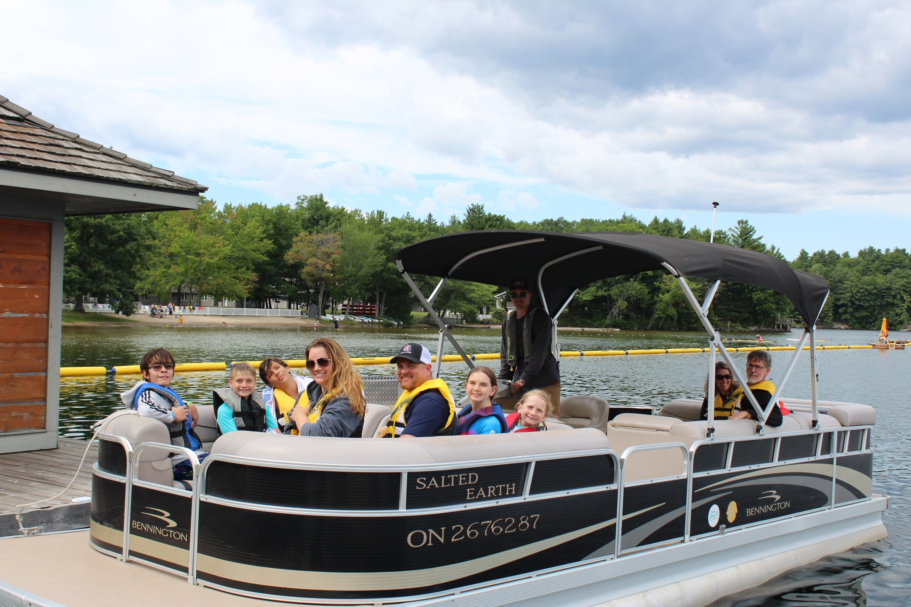
Our Family Programs give people with sight loss and their families an opportunity to enjoy everything Muskoka has to offer on beautiful Lake Joseph in a safe and inclusive environment. Activities are available for all ages and include special events designed for adults, youth and kids.

Welcome to CNIB Lake Joe’s Family Programs
Pre-camp virtual orientation session
Included in the program registration fee, you will be invited to a Zoom meeting to meet other families in advance, go over important details, and get answers to questions. This session will ensure you are fully prepared, so you can spend all of your time on-site at Lake Joe focused on fun, family and friends. Full details will be provided to registrants at the beginning of the season.

Family Weeks
Week 1 – August 4-9, 2025 (priority for families with children with sight loss)
Week 2 – August 18-23, 2025
Experience the beauty of Muskoka at CNIB Lake Joe with our incredible Family Week programs on the stunning stores of Lake Joseph! Whether you’re taking a refreshing dip in the lake, riding a tandem bike, fishing, cruising the waters or unwinding by the campfire, there is something for everyone in the family.
We offer daily kids camps and teen camps for younger guests, while adults can relax and unwind in welcoming environments. This is the perfect opportunity to combine the freedom of a cottage getaway with the fun of traditional summer camp activities, all while creating cherished memories as a family. Whether you are seeking adventure, relaxation or bonding time, CNIB Lake Joe has it all!

Partner Program: CNIB Buddy Dog Camp
August 18-23, 2025 | Ages 7-16
This one-of-a-kind program is designed specifically for CNIB Buddy Dog graduates and combines Buddy Dog training with exciting camp activities. Throughout the week, participants will have the chance to strengthen their bond with their buddy dog while enjoying recreational activities that promote independence, confidence, and teamwork. In addition to traditional camp recreational fun, participants work with expert CNIB Guide Dog trainers, receiving advice and support as they continue to grow with their Buddy Dog.
Important Program Points:
- This program is exclusively for CNIB Buddy Dog graduates who are paired with their guide dog.
- Each participant must be accompanied by a parent or guardian for the duration of the program.
- The program includes Buddy Dog-specific training sessions, as well as recreational camp activities.
To find out more about the CNIB Buddy Dog Camp or the CNIB Buddy Dog Program contact Miriam Mas, Program Lead, Buddy and Ambassador Dog Training at miriam.mas@cnib.ca or 343-997-2498.

There are more programs to explore in our Adult Programs section or return to our table of contents.

CNIBLakeJoe@Home Virtual Programs
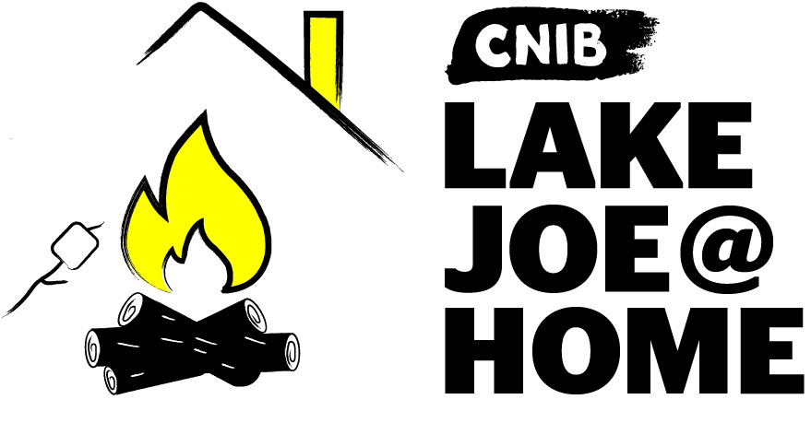

Our virtual programs keep our camp community connected all year long. If you haven’t already participated, please visit CNIBLakeJoe@Home and join us!
We offer a wide range of programs where you can learn and laugh with friends from camp…and friends you haven’t met yet. Join us for weekly coffee break get-togethers, virtual campfires, talent shows, and more. We also offer monthly specialty programs like Curiosity Corner, Music Trivia, Reading Room, holiday celebrations, and more.
Pre-registration is required to access these completely free virtual programs, that you can join by phone and by computer.

But wait, there’s more!
New CNIBLakeJoe@Home virtual sessions are always being added. If you have suggestions for future programs, please leave us a note in our Virtual Suggestion Box.
We also encourage you to explore our online calendar and see what’s happening in your community and connect with friends, new and old.
For more information about CNIBLakeJoe@Home virtual programs, please contact Taylor Gaudon, Virtual Program Coordinator at taylor.gaudon@cnib.ca or 705-375-2630, ext. 5500.

Programs Summary
Browse all our 2025 programs at a glance, broken down by month.

June
- Guide Dogs AdvoCamp: June 5-9, 2025
- Adult Leisure #1: June 23-28, 2025

July
- PLAY: July 7-12, 2025
- Camp Abilities: July 7-12, 2025
- Young Adult Week: July 14-19, 2025
- NEW! Young Adult Wilderness Trip: July 14-19, 2025
- Adult Leisure #2: July 21-26, 2025
- Summer Camp/ESL Immersion: July 28-August 2, 2025
- Leadership Camp: July 28-August 2, 2025
- Counselor-in-Training: July 28-August 9, 2025

August
- Family Week #1: August 4-9, 2025
- Family Week #2: August 18-23, 2025
- CNIB Buddy Dogs: August 18-23, 2025

September
- Orientation & Mobility / Guide Dog Immersion: September 7-12, 2025
P.S. Don’t forget that CNIBLakeJoe@Home virtual programs run year-round!

2025 Program Fees
All camp experiences include meals, accommodations, and all on-site programs and activities. Thanks to the generosity of CNIB supporters, camp costs are highly subsidized to keep registration fees as low as possible. For those guests requiring additional support, such as a Personal Support Worker or Intervenor to attend, there is a rate in place for those individuals who accompany a guest. Further subsidies are available for adults who qualify. Note: All CNIBLakeJoe@Home virtual programs are free-of-charge.
For more information, visit cnib.ca/LakeJoe, email LakeJoe@cnib.ca, or call us at 1-877-748-4028 or 705-375-2630.

Children & Youth Programs
Children & Youth Programs | Full Fee | Deposit  (due April 30) | Final Payment  (due June 2)
PLAY  July 7-12 | $155 | $50 | $105
Camp Abilities  July 7-12 | $155 | $50 | $105
Summer Camp / ESL Immersion  July 28-Aug 2 | $155 | $50 | $105
Leadership Camp  July 28-Aug 2 | $155 | $50 | $105
Counselor-in-Training  July 28-Aug 9 | $155 | $50 | $105

Children & Youth Partner Programs
- ESL Immersion (July 28-Aug 2): Please contact Salma Moudrika at salma.moudrika@inca.ca or 1-800-465-4622 ext. 236.
- CNIB Buddy Dogs (August 18-23): Please contact Miriam Mas at miriam.mas@cnib.ca or 343-997-2498.

Adult Programs
Adult Programs | Full Fee | Deposit  (due April 30) | Final Payment  (due June 2)
Adult Leisure Weeks  June 23-28  July 21-26 | Ages 19-29: $515  Ages 30+:  $745 | $100 | Ages 19-29: $465  Ages 30+:  $645
Young Adult Week  July 14-19 | Ages 19-29: $515  Ages 30-34: $745 | $50 for each fee | Ages 19-29: $465  Ages 30+:  $645
Young Adult  Wilderness Trip  July 14-19 | Ages 19-29: $515  Ages 30-34: $745 | $50 for each fee | Ages 19-29: $465  Ages 30+:  $645

Adult Partner Programs
- Guide Dogs AdvoCamp (June 5-9): Please contact Stephanie Pilon at stephanie.pilon@cnib.ca or (705) 923-9923
- Orientation & Mobility / Guide Dog Immersion (September 7-12): Please contact Tracy Garbutt at tracy.garbutt@cnib.ca, 204-894-6926.

Family Weeks
Family Weeks | Full Fee | Deposit  (due April 30) | Final Payment  (due June 2)
Family Weeks  August 5-10  August 19-24 | Ages 0-5: Free  Ages 6-18: $155  Ages 19-29: $515  Ages 30+: $745 | $25 for each family member | Ages 0-5: Free  Ages 6-18: $120  Ages 19-29: $490  Ages 30+: $720

Support Worker / Intervenor Fees
Support Worker / Intervenor | Full Fee | Deposit  (due April 30) | Final Payment  (due June 2)
Applicable to all weeks | $515 | $50 | $465

Application Process
For information and support, please email LakeJoe@cnib.ca, or call 1-877-748-4028 or 705-375-2630.

Step 1: Apply
Application opens Thursday, January 9, 2025, at 8 am Eastern time.
If you would like to apply to participate in an in-person program at CNIB Lake Joe, please complete the required online application.
If you are new to our online system, you will be required to create an account to apply. If you are returning to our online system, please login to your existing account. Forgot your password? Simply request a new one on the login page and access your existing account.
You will be asked to select the program(s) you would like to attend and, if you are attending with more than one person from your household, add these guests to your application.
Program selections and waiting lists:
- Applications received by February 21: notification of program confirmation will be provided by March 14.
- Applications received after February 21: will be confirmed on an ongoing basis until all remaining program spots have been filled.
- Once programs are filled, applications will be added to the waiting list.
- If you need to cancel your application or come off a waiting list, please let us know as soon as possible by emailing LakeJoe@cnib.ca, or calling 1-877-748-4028 or 705-375-2630.
Need a little extra help with your application? Please contact us LakeJoe@cnib.ca, or call 1-877-748-4028 or 705-375-2630 so we can set an appointment to help you with your application.

Step 2: Pay the Deposit
Deposits will be accepted between April 1 – April 30, 2025.
Starting April 1, 2025, you will be able to access the “deposit payment” section of the registration platform to pay your deposit. You are welcome to make your full payment of camp fees at this time if desired.
Paying by credit card is preferred as payments are confirmed immediately and refunds can be provided swiftly when needed.
If paying by cheque or money order, please expect delays in confirmation of your payment or with any refunds needed Make payable to “CNIB Lake Joe” and send to 4 Joe Finley Way, Mactier, ON P0C 1H0 with a note indicating the guest’s name and the program week they are attending.
Please note that cheques and money orders will not be cashed until after April 1.
If your deposit payment is not received by April 30, your space will be forfeited and given to a waitlisted applicant. We will make every effort to contact you to confirm your plans before forfeiting your space. However, guests are responsible to ensure deposits are made by April 30 to confirm registration.
If you have any concerns with paying your deposit, please email LakeJoe@cnib.ca, or call 1-877-748-4028 or 705-375-2630.

Step 3: Pay the Balance
Any balance owing is due by Monday, June 2, 2025.
After paying your deposit, the remaining camp fees are due on or by Monday, June 2, 2025. Reminder emails and phone calls will be sent to guests who have not paid their fees.
If the full payment is not received by June 2, your space will be forfeited and given to a waitlisted applicant. We will make every effort to contact you to confirm your plans before forfeiting your space.
Registrations after June 2 must be paid for in full.
Cancellations requiring refunds will have a $50.00 administrative fee deducted.
If you have any concerns with paying your balance, please email LakeJoe@cnib.ca, or call 1-877-748-4028 or 705-375-2630.

Getting to Camp
We welcome guests from across Canada and around the world!
CNIB Lake Joe is located at: 4 Joe Finley Way, MacTier, ON P0C 1H0

Arriving by Car?
Please note parking is free but limited. Please park in one of the designated parking spaces.

Directions from Toronto/Southern Ontario*
- Take Hwy 400 north just past Barrie to Hwy 400 extension (formerly Hwy 69)
- Continue north on Hwy 400 to exit 189 for ON-69 toward MacTier/Gravenhurst
- Merge onto Lake Joseph Road (formerly Hwy 69) past Hwy 169
- Turn right onto Joe Finley Way
*GPS often provides directions to take Hwy 407 toll road. The toll road saves approximately 10 minutes from the drive (approx. 2 hours), but at a cost. Please check a website like google.com/maps for directions or remember to adjust GPS settings.

Directions from Northern Ontario
- Take Hwy 69 south to Hwy 400 south
- Continue south on Hwy 400 to exit 207 for ON-69 toward MacTier/Gravenhurst
- Merge onto Lake Joseph Road (formerly Hwy 69)
- Turn left onto Joe Finley Way

Directions from Eastern Ontario
- Take Hwy 417 west to Bruce St/County Road 20 to Hwy 60 west
- Continue on Hwy 60 and merge onto Hwy 11 south
- Take exit 219 for Muskoka Rd 3 toward Huntsville/Aspdin
- Turn right onto Aspdin Rd/Muskoka District Road 3 (Regional Road 3 W)
- Turn right onto Hwy 141 west and turn left onto Lake Joseph Rd (formerly Hwy 69)
- Turn left onto Joe Finley Way

Do You Need Transportation?
We are pleased to work with you to provide transportation from Pearson International Airport and other transportation hubs throughout Ontario. Additional fees may apply.
Once at CNIB Lake Joe, simply head to the Welcome Centre to check-in and receive your room key. We are waiting for you!
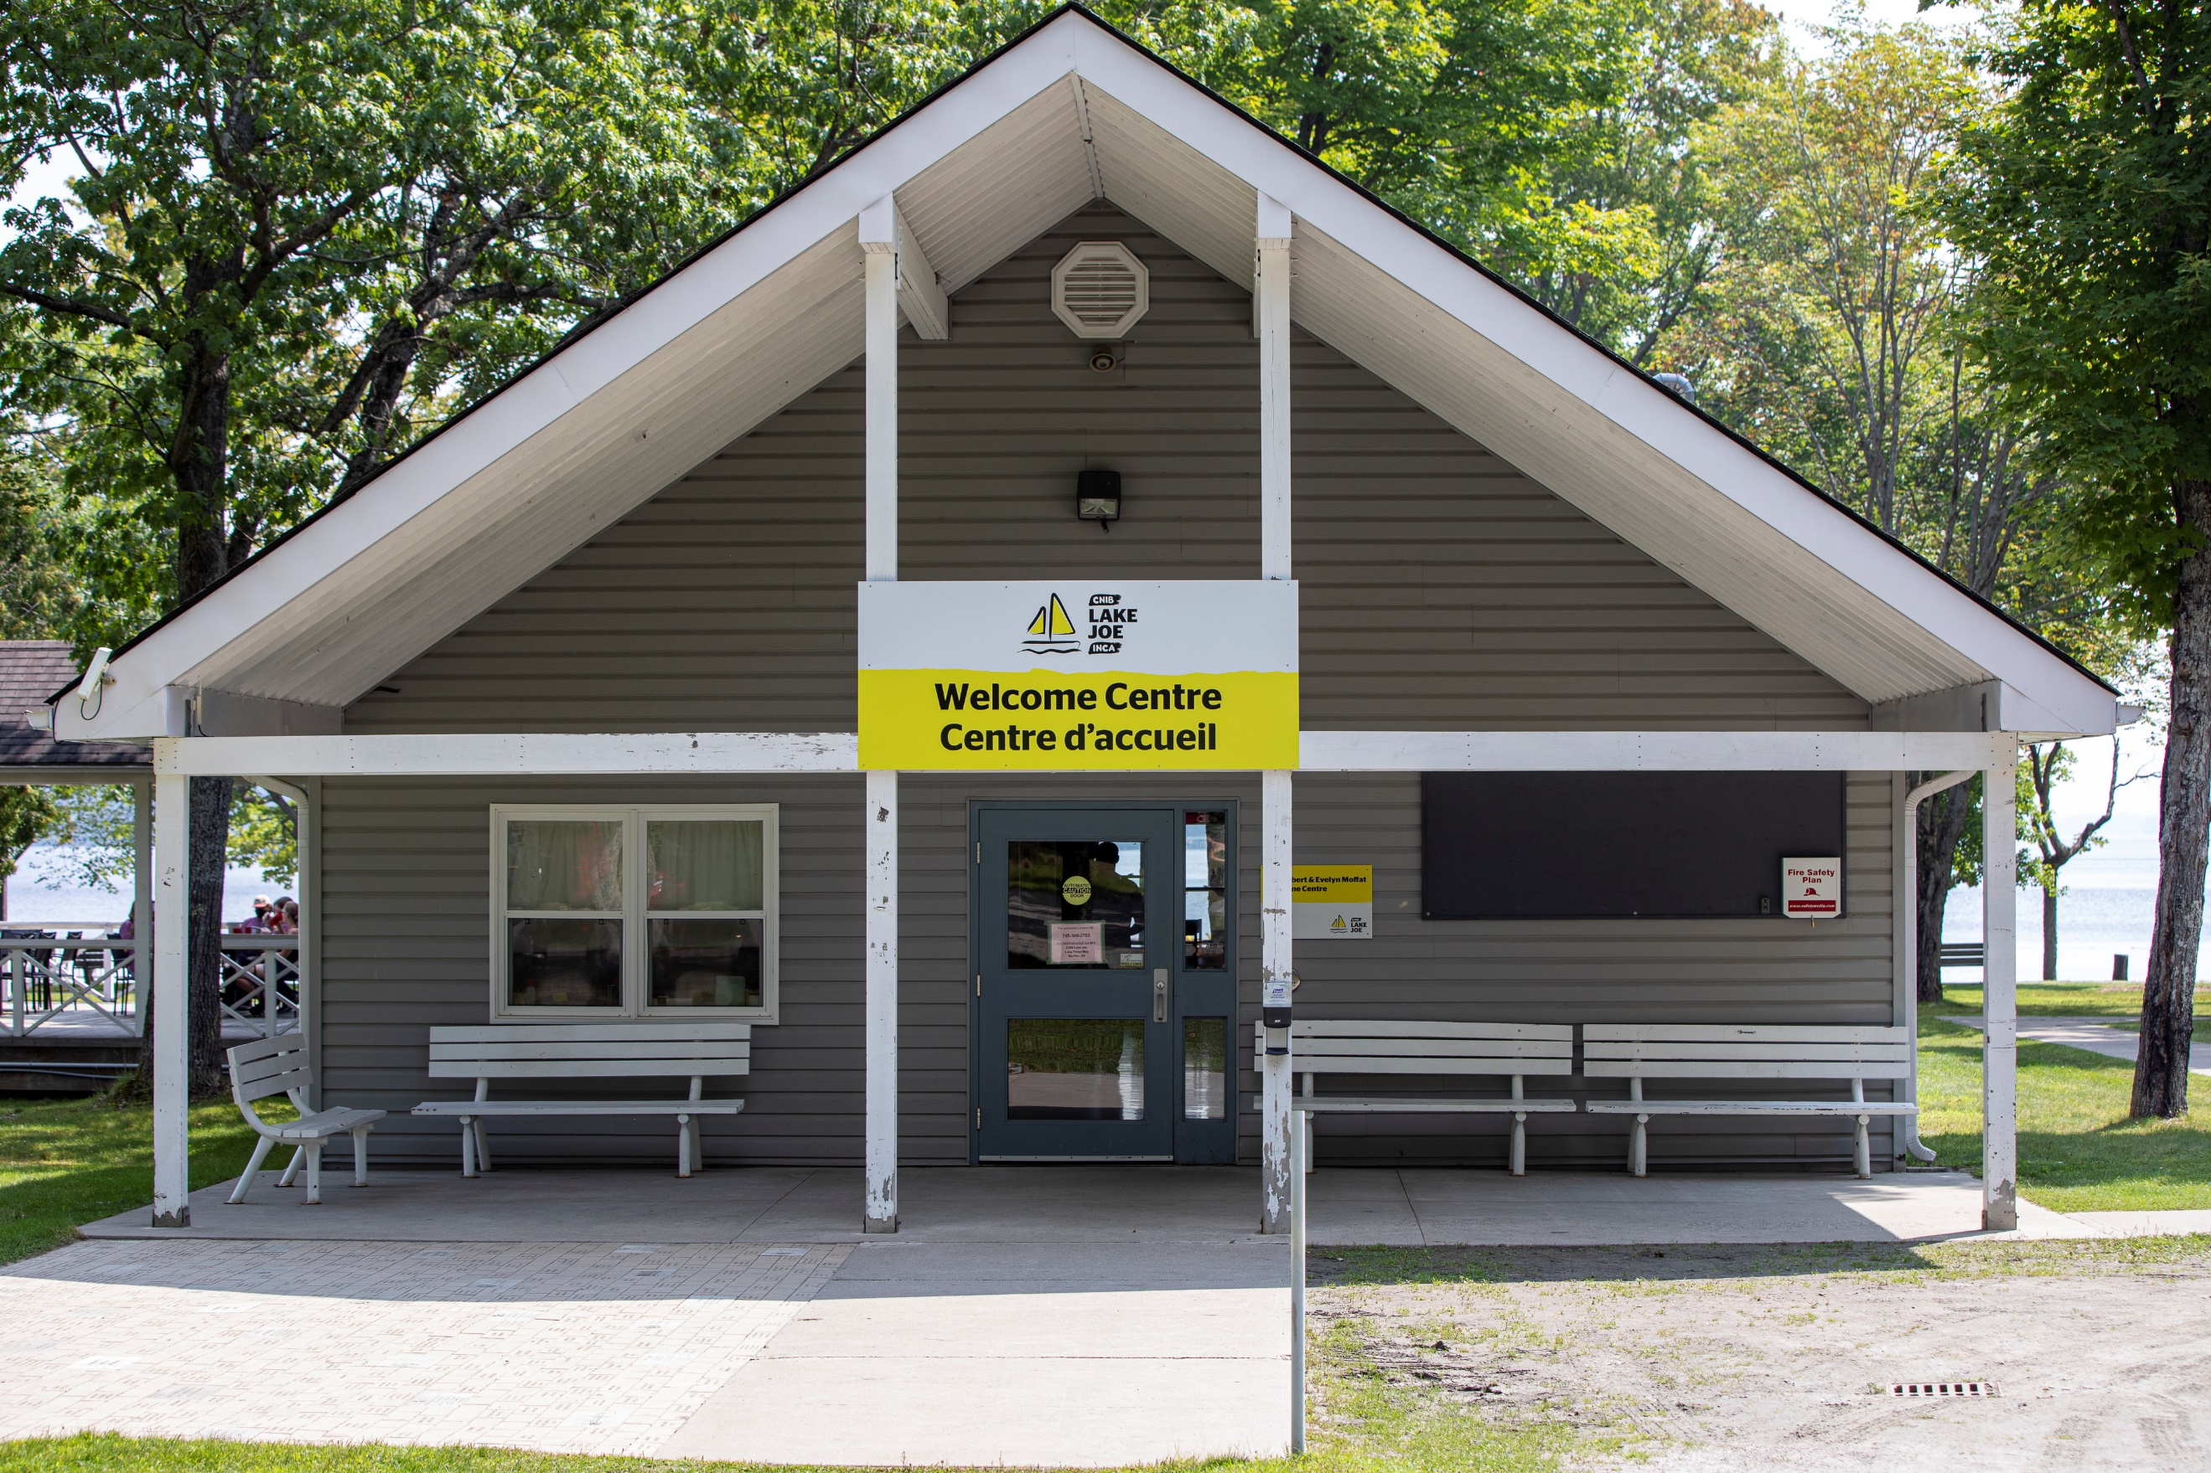

Get Involved
We can’t wait to welcome you to CNIB Lake Joe as our guest, but there are so many ways to enjoy CNIB Lake Joe:
- Participate in CNIBLakeJoe@Home and CNIB virtual programs
- Apply to join our CNIB Lake Joe staff team or recommend someone
- Volunteer at CNIB Lake Joe and make a difference
- Attend an event (visit cnib.ca/LakeJoe for upcoming events)
- Donate to help bring the magic of camp alive at CNIB Lake Joe
- Subscribe to the “Let’s Go: CNIB Lake Joe” e-newsletter
- Follow us on Facebook and Instagram
- Visit CNIB Lake Joe’s YouTube playlist
- Listen to our “CNIB Lake Joe on the Go” podcasts
For more information, visit cnib.ca/LakeJoe, email LakeJoe@cnib.ca, or call 1-877-748-4028 or 705-375-2630.


CNIB Lake Joe
4 Joe Finley Way
MacTier, ON P0C 1H0
Visit: cnib.ca/LakeJoe
Email: LakeJoe@cnib.ca
Toll Free: 1-877-748-4028
Phone: 705-375-2630

